الجمهورية اللبنانية
الاسم والشهرة:--------------------

رقم المرشح :----------------------
وزارة التربية والتعليم العالي الامتحانات الرسمية لشهادة الامتياز الفني
المديرية العامة للتعليم المهني والتقني لدورة عام 2017 الاولى
===============
الاختصاص والرمز : المعلوماتية الادارية ( 23104)
المادة : برمجة ويب Web المعدل: (10)
المستندات المسموح بها : لا شيء المدة : ساعتان

- Write the corresponding HTML5 and JavaScript tags to create the page that shows the number of correct answers about the questions asked in the form mentioned to the right. (4 pts)  The first question: How many objects did HTML5 provide for data storage? Is a Combobox that contains the following values : 1, 2, 4. The correct answer is 2.  The second question: Which HTML5 elements are new?  contains 3 Checkboxes, multiple choice are possible. The correct answer is header and footer.  A click on the "Result" button executes a function that checks for the number of correct answers and then displays the result in a message according to the following form:  "Your score is:" followed by the number of correct answers. | 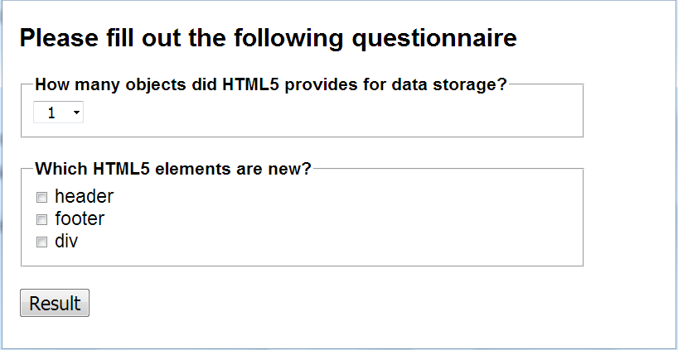

- Write the corresponding HTML5 and JavaScript tags to create the 3 following files: (2 ½ pts)
File 1: index.html  - "Audio" is a link to the file "audio.html".  - "Video" is a link to the file "video.html".  - The link color is green.  - The visited link color is blue.  - The active link color is red.  For colors, use the hexadecimal code, the code rgb or rgba. | 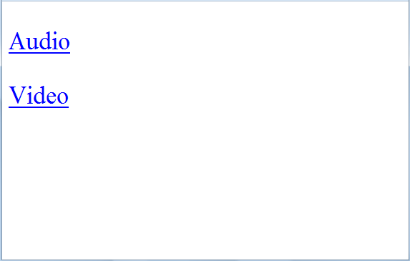  Index.html
File 2: audio.html  As soon as this page is loaded, the audio file "welcome.wav" is played automatically and infinitely. The audio controls are displayed. | 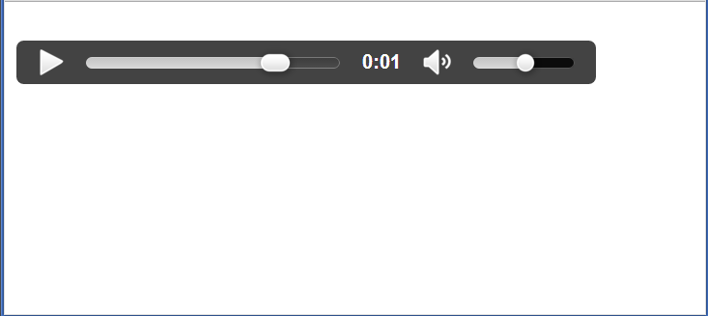  audio.html
File 3: video.html  This page displays the video file "catalog.webm". The video controls are displayed. | 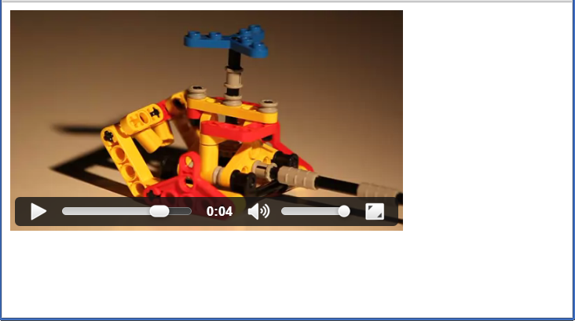  video.html

- By Using "SVG" or "Canvas", write the appropriate HTML5 tags to draw a line in the below page: (2 ½ pts)
The characteristics of the "SVG" or "Canvas" are as follows:  - Width: 200 pixels.  - Height: 150 pixels.  The characteristics of the “line” are as follows:  - Begin point for the line on the x axis is: 30.  - Begin point for the line on the y axis is: 20.  - End point for the line on the x axis is: 150.  - End point for the line on the y axis is: 120.  - Border color is: red.  - Border thickness is: 4 pixels. | 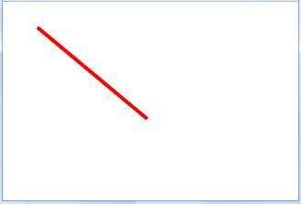

الاختصاص والرمز : المعلوماتية الادارية ( 23104)
المادة : برمجة ويب Web

- Write the appropriate HTML5 tags and the appropriate CSS properties to obtain as a result the page mentioned to the right: (5 pts)  - This page has the following characteristics:  - Space outside the border: 20 pixels.  - Font size is: 1.2 em.  - Font type is: Arial.  - Border Type: dashed.  - Border thickness: 5 pixels.  - Border color: blue.  - The background image is "xyz.png".  - The first line "HTML5" is considered as the biggest title.  - "Affichage dans une carte" is a link to "www.google.com/maps".  - "Storage" is written in bold.  - "Web Workers" is written in italic.  - The image "Back to top" is a link to the top of the page. The name of this image is "abc.png". Its width is 120 pixels and its height is 100 pixels.  - The numbers and the bullets are lists. | 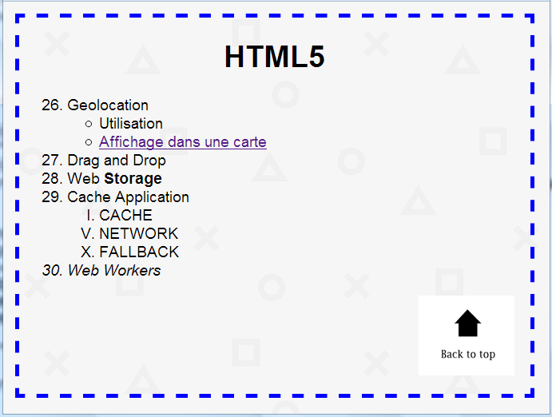

- Write the corresponding HTML5 and JavaScript tags to obtain the below page that stores data entered in a form, locally, (with localStorage) in the browser. (3 pts)
- Indicate the appropriate type for the following fields:
Name, Date of Birth, Favorite Color, Favorite Website.
- After a click, the "Save" button executes a function that locally stores the data entered in 4 variables using the localStorage. Each data is stored in a variable (Name in variable n, Date of Birth in d, Favorite Color in c, Favorite Website in w).
- The "Cancel" button restores the default values of all fields.

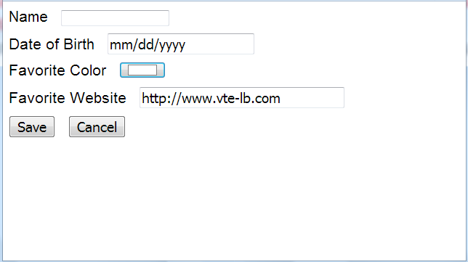

- Write the appropriate HTML5 tags and the appropriate CSS properties to obtain as result the below page. (3 pts)

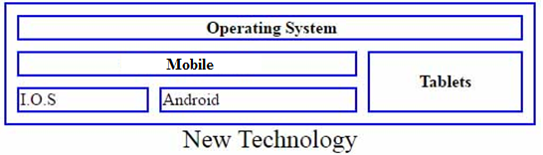

- The table caption is: "New Technology", the caption size is: 24 pixels.
- The table have the following characteristics:
- Width: 500 pixels.
- Height: 50 pixels.
- Space between borders: 10 pixels.

